**DATA 605**

***FINAL PROJECT REPORT***

**A Comprehensive Look into Determining the Primary Driver of Gasoline Prices — Canadian Crude Oil Production or the International Market**

by

**Jannatul Naeema (30198919)**

**Introduction**

Canada is one of the largest crude oil producers in the world, with significant reserves of both conventional and unconventional oil; this fact, coupled with recent spikes in gas prices, has inspired me to undertake a project aimed at gaining a deeper understanding of the Canadian oil production and export industry. By conducting a thorough analysis of the production and export data available, I hope to shed light on the Canadian crude oil market and identify the key factors driving recent price fluctuations.

**Datasets**

Total 3 datasets have been used for this project.

*1.*[*Dataset-1:*](https://www150.statcan.gc.ca/t1/tbl1/en/tv.action?pid=2510006301&pickMembers%5B0%5D=1.1&cubeTimeFrame.startMonth=01&cubeTimeFrame.startYear=2019&cubeTimeFrame.endMonth=12&cubeTimeFrame.endYear=2022&referencePeriods=20190101%2C20221201)Supply and disposition of crude oil and equivalent, This is a monthly collected survey to collect administrative data provided by federal, provincial and territorial authorities responsible for the regulation of crude oil and natural gas production for the provinces and territories within their respective jurisdictions. Data is compiled on crude oil and natural gas production, net withdrawals, imports and exports, domestic deliveries, inventory change for Canada and the provinces and territories. The columns used for this project are,

***REF_DATE:***Date,***GEO:*** Provinces and Territories, ***Supply and disposition:*** Total supply could be calculated by adding Crude oil production, Equivalent products production, and Imports. Total disposition could be calculated by adding Input to Canadian refineries, Exports, and Inventory changes. ***VALUE:*** Corresponding quantity of Oil

*2.*[*Dataset -2*](https://www150.statcan.gc.ca/t1/tbl1/en/tv.action?pid=1810000101)*:* Monthly average retail prices for gasoline and fuel oil, by geography; used columns are,

***REF_DATE:*** Date, ***GEO:***Provinces and Territories, ***Type of fuel:*** 4 types of fuel; Regular unleaded gasoline at full service filling stations, Diesel fuel at self service filling stations, Diesel fuel at self service filling stations, Household heating fuel, ***VALUE:*** Price of fuel in cents/L

3. [Dataset-3:](https://ca.investing.com/commodities/crude-oil-historical-data) International market price of Crude Oil WTI, monthly value is downloaded. ***Date*** and ***Price*** columns were used from this dataset.

**Guiding Questions**

1. Was there a disruption in Canada’s crude oil production and import of crude oil during both the Covid pandemic and the ongoing Russia-Ukraine war?
2. What was the status of crude oil production, import, and export in each province of Canada before COVID-19 in 2019, and after COVID-19 in 2022? Which countries are the primary importers of Canadian crude oil and which method of transportation is most commonly used?
3. Has a substantial portion of the crude oil produced been subject to further processing in Canadian refineries? Which provinces import most of crude oil?
4. Does Gasoline price in Canada fluctuates with international market price? Does it depend on Crude oil production?
5. What is the insight of provincial gasoline price in last few years?

**Tools:**The analysis and visualization is done with MS Excel, Tableau and Tableau Public.

**Analysis**

***Question 1.****Was there a disruption in Canada’s crude oil production and import of crude oil during both the Covid pandemic and the ongoing Russia-Ukraine war?*

To answer the question, I utilized dataset-1, and processed the data by replacing any null values with zeroes; then plotted the graph on tableau. Based on the dataset, crude oil production decreased significantly following the outbreak of COVID-19 in 2020, reaching its lowest point in May of that year. However, production then began to rebound, ultimately reaching its highest level in the past five years in December 2020, at 139 million. Similarly, oil imports decreased in April 2020, and have remained relatively consistent since that time.

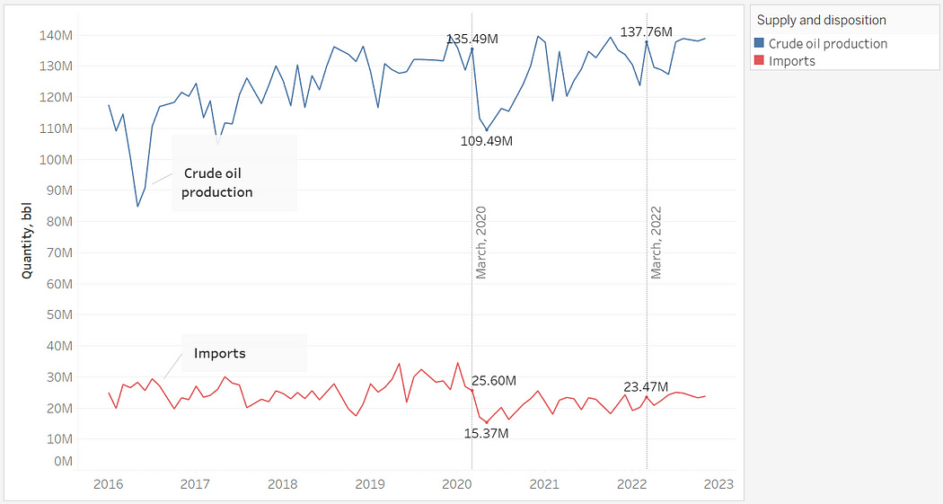

<https://public.tableau.com/app/profile/jannatul6930/viz/ImpactofCovidandWaronCrudeOilProductionandImport/sheet6>

The accompanying plot clearly shows that while imports decreased in the wake of COVID-19, production ramped up significantly to compensate for the loss. Although the production experienced a slight drop following the Russia-Ukraine war, it began to pick up again in June of last year.

***Question 2.****Has a substantial portion of the crude oil produced been subject to further processing in Canadian refineries? Which provinces import most of crude oil?*

In order to address the inquiry, in tableau an area chart was used to visually represent the aggregated quantity of crude oil within dataset-1. Analysis of the resulting chart reveals that a substantial portion of crude oil is exported annually. Additionally, approximately less than one-third of produced crude oil is utilized as input to Canadian refineries. But, small quantity imported of crude oil is employed for further processing in Canadian refineries.

<https://public.tableau.com/app/profile/jannatul6930/viz/AreaChartofNationalProductionImportExportandRefining/sheet5>

In next step to gain a more comprehensive understanding of the provincial contributions to the above-mentioned area chart, I have created a dashboard on Tableau Public. The initial graph within the dashboard displays the aggregated quantities of crude oil imports and inputs to Canadian refineries across various provinces from 2016 to 2022. Additionally, the second and third graphs within the dashboard provide detailed comparisons of national crude oil production, imports, and refinery inputs for each year. Through the utilization of this dashboard, a more detailed analysis of the provincial contributions to the aforementioned area chart is performed, to get a better grasp of the situation.

<https://public.tableau.com/app/profile/jannatul6930/viz/NationalandProvincialProductionImportandRefining/Dashboard2>

Ontario, Quebec, Saskatchewan, and Manitoba are the provinces in Canada that import the greatest quantities of crude oil. In contrast, Alberta stands out as the most significant contributor to Canadian refineries due to its position as the largest producer of crude oil among all the provinces.

***Question 3.****What was the status of crude oil production, import, and export in each province of Canada before COVID-19 in 2019, and after COVID-19 in 2022? Which countries are the primary importers of Canadian crude oil and which method of transportation is most commonly used?*

As shown on the following Tableau dashboard that there has been little change in the overall annual crude oil production between the years 2019 to 2022. As previously noted, Alberta remains the largest producer of crude oil and also emerged as the most substantial exporter of crude oil since 2020, which can be attributed to a regulatory change.

*As*[*of reference month January 2020, changes were made to the methodology for exports of crude oil by pipeline. These volumes are now allocated to the province where the product was loaded, as opposed to the province of clearance at the Canada — United States border (before January 2020)*](https://www150.statcan.gc.ca/t1/tbl1/en/tv.action?pid=2510006301&pickMembers%5B0%5D=1.1&cubeTimeFrame.startMonth=01&cubeTimeFrame.startYear=2019&cubeTimeFrame.endMonth=12&cubeTimeFrame.endYear=2022&referencePeriods=20190101%2C20221201)*— source: statcan.gc.ca*

<https://public.tableau.com/app/profile/jannatul6930/viz/NationalandProvincialProductionImportandRefining/Dashboard1>

Canada’s largest crude oil export partner is the United States due to their shared border. However, the outbreak of the COVID-19 pandemic resulted in a significant reduction in crude oil exports beginning in March 2020 as shown in the dashboard. But, by June of the same year, crude oil exports had subsequently recovered. The two countries share the longest international border in the world, which has enabled the development of an extensive pipeline network for transporting crude oil from Canada to the United States. The trendline in the graph for crude oil exports via pipelines to the United States has shown a substantial increase since 2016.

***Question 4.****Does Gasoline price in Canada fluctuates with international market price? Does it depend on Crude oil production?*

Gasoline prices in Canada and the international market have fluctuated over the past three years. In an effort to better understand the factors driving these changes, I conducted an analysis using datasets 1 and 2 on Tableau. I utilized the “Crude Oil Production Quantity” column from dataset 1 and the “Price” column from dataset 2, which were plotted against years on the x-axis. The resulting graph reveals a generally consistent trend, wherein increases in crude oil production quantities are accompanied by price increases and decreases in production quantities coincide with price decreases up to 2021. However, in 2022, despite a slightly lower production quantity than the previous year, prices have increased significantly. These findings suggest that there are other factors driving gasoline prices beyond crude oil production quantities.

<https://public.tableau.com/app/profile/jannatul6930/viz/GasolinePriceandQuantityofCrudeOilProduction/Sheet1>

In addition to fluctuations in the Canadian gasoline market, the international market has also experienced notable price changes in recent years. To gain a comprehensive understanding of these trends, I employed datasets 2 and 3 in my analysis and created graphs on Tableau to investigate price fluctuations in both the local and international markets. In dataset 3, the gas price was converted from USD/bbl to cents/L (CAD) for consistency with the data in dataset 2. The resulting graphs reveal similar trends in price fluctuations in both the local and international markets. These findings suggest that global factors may be playing a role in the price of gasoline, which underscores the importance of considering international market trends in any analysis of the Canadian gasoline market.

<https://public.tableau.com/app/profile/jannatul6930/viz/GasolinePriceinCanada/Dashboard2>

Gas Price at International Market <https://public.tableau.com/app/profile/jannatul6930/viz/GasPriceatInternationalMarket/Dashboard1#1>

It’s worth noting that gasoline prices can vary significantly from country to country and even within a country, depending on local taxes and other factors.

***Question 5.****What is the insight of provincial gasoline price in last few years?*

The preceding section has provided an overview of gas prices. In order to gain a understanding of provincial price variation, a box plot of provincial gas prices has been plotted. The results show that during the COVID-19 pandemic in 2020, the gas prices in the other provinces were more closely distributed with lower variance, as demonstrated by the box plots. However, in 2022, the gas prices show a greater variance with prices observed across the provinces.

Regular Gas Price at Different Provinces (2012–2022)  [https://public.tableau.com/app/profile/jannatul6930/viz/RegularGasolinePriceatdifferentprovinces/Dashboard2](https://public.tableau.com/app/profile/jannatul6930/viz/GasolinePriceatdifferentCanadiancities/Sheet1)

As evidenced by the graph, the lowest gas prices during the COVID-19 pandemic in 2020 were observed in Edmonton, and this trend continued in the subsequent years, with Edmonton consistently having the lowest gas prices among all provinces. Conversely, gas prices in Vancouver were consistently higher than any other province, which could be attributed to higher taxes in that region.

<https://public.tableau.com/app/profile/jannatul6930/viz/GasolinePriceatdifferentCanadiancities/Dashboard1>

**Conclusions:**

In conclusion, the COVID-19 outbreak has disrupted crude oil production and distribution, and various factors have contributed to the increase in gasoline prices. It is evident that international oil market dynamics play a significant role in determining the prices, rather than just local oil production or distribution.

**References:**

1. Canada Energy Regulator: Provincial and Territorial Energy Profiles — Canada [Online]. Available at: <https://www.cer-rec.gc.ca/en/data-analysis/energy-markets/provincial-territorial-energy-profiles/provincial-territorial-energy-profiles-canada.html> (Accessed January 28, 2023)
2. International market price of Crude Oil WTI [Online]. Available at: <https://ca.investing.com/commodities/crude-oil-historical-data> (Accessed February 10, 2023)
3. Monthly average retail prices for gasoline and fuel oil, by geography [Online]. Available at: <https://www150.statcan.gc.ca/t1/tbl1/en/tv.action?pid=1810000101> (Accessed January 28, 2023)
4. Supply and disposition of crude oil and equivalent [Online]. Available at: <https://www150.statcan.gc.ca/t1/tbl1/en/tv.action?pid=2510006301&pickMembers%5B0%5D=1.1&cubeTimeFrame.startMonth=01&cubeTimeFrame.startYear=2019&cubeTimeFrame.endMonth=12&cubeTimeFrame.endYear=2022&referencePeriods=20190101%2C20221201> (Accessed January 25, 2023)